**Exercise 1: Control Structures**

**Database Setup**

To implement the following scenarios, I first created the required tables customers and loans using PL/SQL and inserted sample data. I also downloaded the table data, and will attach it below for reference.

**Attached Tables:**

* **customers_table_output.csv**

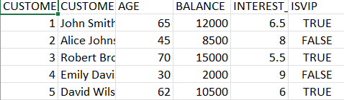

* **loans_table_output.csv**

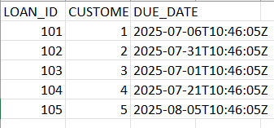

These tables include fields such as customer_id, customer_name, age, balance, interest_rate, IsVIP, and due_date, which are used in the PL/SQL programs below.

**Scenario 1: Discount for Senior Citizens**

**Question:** Write a PL/SQL block that loops through all customers, checks their age, and if they are above 60, apply a 1% discount to their current loan interest rates.

DECLARE

CURSOR cur_customers IS

SELECT customer_id, interest_rate

FROM customers

WHERE age > 60;

BEGIN

FOR rec IN cur_customers LOOP

UPDATE customers

SET interest_rate = interest_rate - 1

WHERE customer_id = rec.customer_id;

DBMS_OUTPUT.PUT_LINE('1% discount applied to customer ID: ' || rec.customer_id);

END LOOP;

END;

/

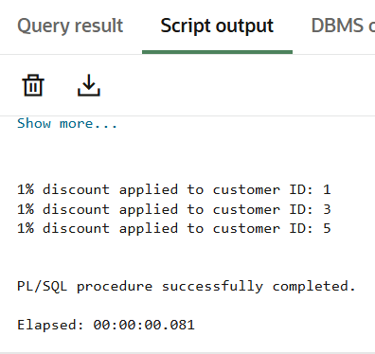

**Scenario 2: Promote to VIP**

**Question:** Write a PL/SQL block that iterates through all customers and sets a flag IsVIP to TRUE for those with a balance over $10,000.

DECLARE

CURSOR cur_vip_check IS

SELECT customer_id, balance

FROM customers

WHERE balance > 10000;

BEGIN

FOR rec IN cur_vip_check LOOP

UPDATE customers

SET IsVIP = 'TRUE'

WHERE customer_id = rec.customer_id;

DBMS_OUTPUT.PUT_LINE('Customer ID ' || rec.customer_id || ' promoted to VIP.');

END LOOP;

END;

/

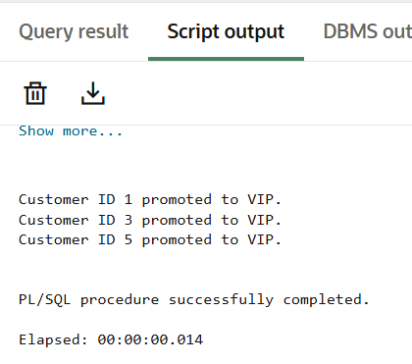

**Scenario 3: Loan Payment Reminders**

**Question:** Write a PL/SQL block that fetches all loans due in the next 30 days and prints a reminder message for each customer.

DECLARE

CURSOR cur_due_loans IS

SELECT loan_id, customer_id, due_date

FROM loans

WHERE due_date BETWEEN SYSDATE AND SYSDATE + 30;

BEGIN

FOR rec IN cur_due_loans LOOP

DBMS_OUTPUT.PUT_LINE('Reminder: Loan ID ' || rec.loan_id ||

' for Customer ID ' || rec.customer_id ||

' is due on ' || TO_CHAR(rec.due_date, 'DD-MON-YYYY'));

END LOOP;

END;

/

